4) Java Script & XML
4.1) Write a JavaScript to validate the following fields in a registration page created in week 2
a. Name (start with alphabet and followed by alphanumeric and the length should not be less than 6 characters)
b. Password (it allows alphanumeric, special symbols and should not be less than 6 characters)
c. E-mail (should not contain invalid email addresses)
<html>
<head><h1 align=center>Welcome to Validation
Checking</h1><hr width=50%>
<script language="javascript">
function validation()
{
var x=f.un.value;var len=x.length;
var val=x.charCodeAt(0); var p=f.pw.value;
var c=f.cpw.value;var a=f.email.value;
var atpos=a.indexOf("@");var dotpos=a.lastIndexOf(".");
if(len<6||x==""||x==null)
{
alert("check your username! must be minimum 6 characters");
}
else if(val<65 || val>90&&val<97 || val>122)
{
alert("username must be begin with an alphabet");
return fasle;
}
else if(p==" || c==" || p.length<6 || c.length<6 || p!=c)
{
alert("password and confirm password should be same and greater than 6 characters!");
return false;
}
else if(atpos<6 || dotpos<atpos+6 || dotpos+2>=a.length)
{
alert("Not a Valid email id");
return false;
}
else
alert("Congratulations!you have submitted successfully");
}
</script>
</head>
<body>
<table align=center border=I>
<form name="f" action="success.html" onsubmit="return validation();" method="post">
<tr><td>User Name:</td>
<td><input type="text" name="un"/></td></tr>
<tr><td>Password:</td>
<td><input type="password" name="pw"/></td></tr>
<tr><td>Confirm Password:</td>
<td><input type="password" name="cpw"/></td></tr>
<tr><td>E-mail ID:</td>
<td><input type="text" name="email"/></td></tr>
<tr><td></td>
<td><input type="Submit" name="Submit"/></td></tr>
</form></table></body></html>
OUTPUT:
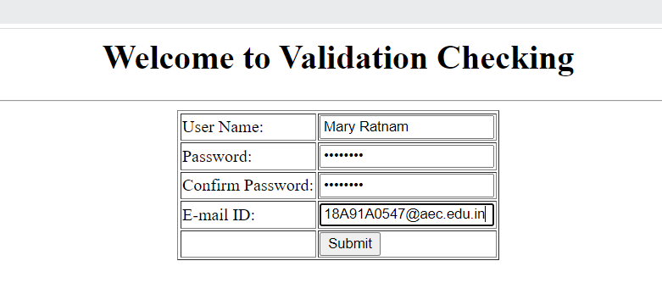
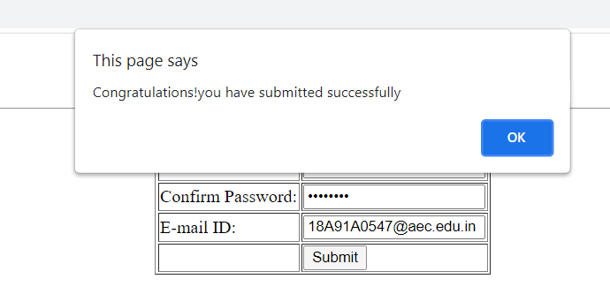
4.2) Write an XML file which will display the Book information which includes the following:
a) Title of the book ;b) Author Name ;c) ISBN number ;d) Publisher name
e) Edition ;f) Price
Write a Document Type Definition (DTD) to validate the above XML file and display the details in a table (to do this use XSL).
Book.dtd:
<!ELEMENT bookdetails(books+)>
<!ELEMENT books(title,author,isbn,publisher,edition,price)>
<!ELEMENT title(#PCDATA)>
<!ELEMENT author(#PCDATA)>
<!ELEMENT isbn(#PCDATA)>
<!ELEMENT publisher(#PCDATA)>
<!ELEMENT edition(#PCDATA)>
<!ELEMENT price(#PCDATA)>
Book.xml:
<?xml version="1.0"?>
<!DOCTYPE bookdetails SYSTEM "book.dtd">
<?xml-stylesheet type="text/xsl" href="book.xsl"?>
<bookdetails>
<books>
<title>C</title>
<author>Balaguruswamy</author>
<isbn>123456</isbn>
<publisher>Oxford</publisher>
<edition>Edition-II</edition>
<price>$30.00</price>
</books>
<books>
<title>C++</title>
<author>yaswanth kanethkar</author>
<isbn>654321</isbn>
<publisher>Tata McHill</publisher>
<edition>Edition-I</edition>
<price>$35.00</price>
</books>
<books>
<title>JAVA</title>
<author>Herbert Schildt</author>
<isbn>789456</isbn>
<publisher>Cenage</publisher>
<edition>Edition-IV</edition>
<price>$50.00</price>
</books></bookdetails>
Book.xsl:
<?xml version="1.0"?>
<xsl:stylesheet version="2.0" xmlns:xsl="http://www.w3.org/1999/XSL/Transform">
<xsl:template match="/">
<html>
<head><center>Book Details</center></head>
<body>
<hr width="50%"/>
<table border="1" align="center">
<tr>
<th>TITLE</th>
<th>AUTHOR</th>
<th>ISBN</th>
<th>PUBLISHER</th>
<th>EDITION</th>
<th>PRICE</th>
</tr>
<xsl:for-each select="bookdetails/books">
<tr>
<td><xsl:value-of select="title"/></td>
<td><xsl:value-of select="author"/></td>
<td><xsl:value-of select="isbn"/></td>
<td><xsl:value-of select="publisher"/></td>
<td><xsl:value-of select="edition"/></td>
<td><xsl:value-of select="price"/></td>
</tr>
</xsl:for-each>
</table></body></html></xsl:template>
</xsl:stylesheet>a
OUTPUT:
